|  |
| --- |
| **CAR RENTAL WEB PAGE**  **A PROJECT REPORT SUBMITTED TO**    **SRM INSTITUTE OF SCIENCE & TECHNOLOGY**   **IN PARTIAL FULFILMENT OF THE REQUIREMENTS FOR THE**   **AWARD OF THE DEGREE OF**    **MASTER OF COMPUTER APPLICATIONS**  **BY**    **LOGESH H**  **REG NO. RA2232241010107**   **SURYA S**  **REG NO. RA2232241010110**    **ARAVINTHAN M**  **REG NO. RA2232241010074**  **UNDER THE GUIDANCE OF**  **Dr. M. PANDIYAN. MCA, M. Phil, PhD**    **DEPARTMENT OF COMPUTER APPLICATIONS**   **COLLEGE OF SCIENCE AND HUMANITIES SRM INSTITUTE OF SCIENCE & TECHNOLOGY**  Kattankulathur – 603 203 Chennai, Tamil Nadu  **October - 2023** |

|  |
| --- |
| **BONAFIDE CERTIFICATE**  This is to certify that the project report titled “CAR RENTAL WEWPAGE” is a bonafide work carried out by SURYA S (RA2232241010110), ARAVINTHAN M (RA2232241010074), LOGESH H (RA2232241010107), under my supervision for the award of the Degree of Master of Computer Applications. To my knowledge the work reported herein is the original work done by these students.  **Dr . M. PANDIYAN Dr . S. Albert Antony Raj**  Assistant Professor, Deputy Dean & Head,  Department of Computer Applications Department of Computer Applications  (GUIDE)  **INTERNAL EXAMINER EXTERNAL EXAMINER** |

|  |  |  |
| --- | --- | --- |
| |  | | --- | |  |   **Declaration of Association of Research Project with SDG Goals**  This is to certify that the research project entitled **CAR RENTAL WEBPAGE** carried out by **LOGESH H(RA2232241010107), ARAVINTHAN M (RA2232241010074),**  **SURYA S(RA2232241010110)** under the supervision of Dr M. PANDIYAN, ASSISTANT PROFESSOR of COMPUTER APPLICATIONS in partial fulfilment of the requirement for the award of Post-Graduation program has been significantly or potentially associated with SDG Goal No **9** titled **INDUSTRY, INNOVATION AND**  **INFRASTRUCTURE.**  This study has clearly shown the extent to which its goals and objectives have been met in terms of filling the research gaps, identifying needs, resolving problems, and developing innovative solutions locally for achieving the above-mentioned SDG on a National and/or on an international level.  **Signature of the Student Guide and Supervisor**  **Head of the Department**  **3** | |
|

|  |  |
| --- | --- |
| **ACKNOWLEDGEMENT**  With profound gratitude to the ALMIGHTY, we take this chance to thank the people who helped us to complete this project.  We take this as a right opportunity to say THANKS to my parents who are there to stand with me always with the words “YOU CAN”.  We are thankful to **Dr. T. R. Paarivendhar**, Chancellor, SRM Institute of Science & Technology who gave us the platform to establish me to reach greater heights.  We earnestly thank **Dr. A. Duraiswamy**, Dean, College of Science and Humanities, SRM Institute of Science & Technology who always encourage us to do novel things.  We express our sincere thanks to **Dr. S. Albert Antony Raj**, Deputy Dean and Head, Department of Computer Applications, College of Science and Humanities for his valuable guidance and support to execute all incline in learning.  It is our delight to thank our project guide **Dr. M. PANDIYAN**, Assistant Professor, Department of Computer Applications for his help, support, encouragement, suggestions, and guidance throughout the development phases of the project.  We convey our gratitude to all the faculty members of the department who extended their support through valuable comments and suggestions during the reviews.  A great note of gratitude to friends and people who are known and unknown to us who helped in carrying out this project work a successful one.  **LOGESH H**  **SURYA S**  **ARAVINTHAN M**  **4** | |
|

|  |  |  |  |  |  |  |  |
| --- | --- | --- | --- | --- | --- | --- | --- |
| **CONTENTS**   |  |  |  | | --- | --- | --- | | **Chapter** | **Title** | **Page No** | | **1**  **2**  **3**  **4**  **5**  **6**  **7**  **8**  **9**  **10**  **11** | Abstract  Introduction  System Analysis   ØExisting System   ØProposed System  System Specification:   ØHardware Specification   ØSoftware Specification   ØSoftware Description  System Design:   ØFlow Chart   ØData Flow Diagram   ØDatabase Diagram  System Implementation – Module description  Input / Output  Sample code  Future Enhancement  Conclusion  Bibliography | 5  7  8  9  22  29  30  35  48  49  50 |   **5** | |
|

|  |  |
| --- | --- |
| **ABSTRACT**  The Project is designed to aid the car rental company to enable renting of cars through on online system. It helps to search for available cars view profile and book the cars for the time period. This system saves time and labour availability. The User has to enter his details and check for the cars available for rent. The main advantage is that the user shall be able to choose a car depending on his budget.  When it comes to cab rental services, It is the most trusted and reliable name in the travel business. The most advanced travel agents offering cab rental and car hire in India, making full use of information technology to improve the level of our efficiency. However, this is only one aspect of services. And this project continually strives to offer the best of services - both in terms of man and machine, to our clients.  Moreover, this project has a fleet of cars ranging from luxury to budget cabs. While, it offers online cab hire service for corporate houses. And this project clam to offer the best of rates, which are tailor-made depending upon the facilities, availed and offer both intercity and intra-city cab facilities.  **6** | |
|

|  |  |
| --- | --- |
| **INTRODUCTION**  We aim to become a pioneer in the vehicle rental industry by completely focusing on customers, our employees, growth, innovation and efficiency. All of these elements will drive us towards success and show us as one company that can perform and give value for money.  When it comes to car rental services, Car rental service is the most trusted and reliable name in the travel business. The most advanced travel agents offering car rental and car hire in India, making full use of information technology to improve the level of our efficiency. However, this is only one aspect of services. And this project continually strives to offer the best of services - both in terms of man and machine, to our clients. All cabs have proper permits and documentation so that the clients couldn't be hassled for the lack of documents. However, this project has strategic backup system for any eventuality. The cab service includes all categories of cars from luxury to budget.  **7** | |
|

|  |  |
| --- | --- |
| **SYSTEM ANALYSIS**  **EXISTING SYSTEM**  ØCar rental service will help users to book a car for some fee specified.  ØTill now there was no clear web based UI to help the users to rent the vehicle.  ØThey had to manually rent the vehicle through their offices.  ØIt was a difficult task to manage rental vehicles.  ØKeeping track of all the rental cars was a problem.  **PROPOSED SYSTEM**  ØThis tool will enable the user to rent a vehicle. The user shall login to the system and check for availability of cars.  ØThe user specifies a type of car and the journey date and <me.  ØThe system shall check for the availability of the car and rent the car to the customer.  ØThe tool is designed using PHP. All the data regarding the rental cars are stored in MySQL database.  ØThe user has to enter his name, address, phone details and check for the cars available for rent.  ØThe UI is very simple and the connec<vity to backend is robust.  ØThe main advantage is that the user shall be able to choose a car depending on his budget.  **8** | |
|

|  |  |
| --- | --- |
| **SYSTEM SPECIFICATION**  **HARDWARE SPECIFICATION**  The minimum hardware requirement of this project is as follows:  Processor : i3 processor  Speed : 4GB of RAM  RAM : 4 GB or above  Monitor : 15 inch colour  Hard disk : 20 GB  Floppy drive : 1.44 MB  Key board : Standard 102 keys  Mouse : 3 buttons  **SOFTWARE SPECIFICATION**  This section lists the requirements that are needed to run the system  efficiently. The operating system needed for the system to run effectively, the  interface to run the application, the driver for running PHP based application, the  integrated development environment to develop the application, and the third-  party tool used for editing purposes are as follows:  **9** | |
|

|  |  |
| --- | --- |
| Languages Used : HTML, CSS, Javascript, Bootstrap, PHP  Back End : MySQL  Web Server : WAMP, XAMPP  Operating System : Windows 10 **SOFTWARE**  **DESCRIPTION**  **LANGUAGES USED**  **HTML**    Hypertext Markup Language (HTML) is the standard markup language  for documents designed to be displayed in a web browser. It can be assisted by  **10** | |
|

|  |  |
| --- | --- |
| technologies such as Cascading Style Sheets (CSS) and scripting languages such as JavaScript. Web browsers receive HTML documents from a web server or from local storage and render the documents into multimedia web pages. HTML describes the structure of a web page semantically and originally included cues for the appearance of the document.  HTML elements are the building blocks of HTML pages. With HTML constructs, images and other objects such as interactive forms may be embedded into the rendered page. HTML provides a means to create structured documents by denoting structural semantics for text such as headings, paragraphs, lists, links, quotes and other items. HTML elements are delineated by tags, written using angle brackets. Tags such as <img/> and <input/> directly introduce content into the page. Other tags such as <p> surround and provide information about document text and may include other tags as sub-elements. Browsers do not display the HTML tags, but use them to interpret the content of the page.  HTML can embed programs written in a scripting language such as JavaScript, which affects the behaviour and content of web pages. Inclusion of CSS defines the look and layout of content. The World Wide Web Consortium (W3C), former maintainer of the HTML and current maintainer of the CSS standards, has encouraged the use of CSS over explicit presentational HTML since 1997.  **11** | |
|

|  |  |
| --- | --- |
| **CASCADING STYLE SHEET(CSS)**    Cascading Style Sheets (CSS) is a style sheet language used for describing the presentation of a document written in a markup language like HTML.CSS is a cornerstone technology of the World Wide Web, alongside HTML and  JavaScript.CSS is designed to enable the separation of presentation and content, including layout, colors, and fonts.  This separation can improve content accessibility, provide more flexibility and control in the specification of presentation characteristics, enable multiple web pages to share formatting by specifying the relevant CSS in a separate .css file, and reduce complexity and repetition in the structural content. CSS information can be provided from various sources. These sources can be the web browser, the user and the author.  The information from the author can be further classified into inline, media type, importance, selector specificity, rule order, inheritance and property definition. CSS style information can be in a separate document or it can be embedded into an HTML document. Multiple style sheets can be imported. Different styles can be applied depending on the output device being used; for  **12** | |
|

|  |  |
| --- | --- |
| example, the screen version can be quite different from the printed version, so that authors can tailor the presentation appropriately for each medium.  The style sheet with the highest priority controls the content display.  Declarations not set in the highest priority source are passed on to a source of lower priority, such as the user agent style. The process is called cascading. One of the goals of CSS is to allow users greater control over presentation. Someone who finds red italic headings difficult to read may apply a different style sheet. Depending on the browser and the web site, a user may choose from various style sheets provided by the designers, or may remove all added styles and view the site using the browser's default styling, or may override just the red italic heading style without altering other attributes.  **JAVASCRIPT**    JavaScript s a high-level, interpreted scripting language that conforms to the ECMAScript specification. JavaScript has curly-bracket syntax, dynamic typing, prototype-based object-orientation, and first-class functions. Alongside HTML and CSS, JavaScript is one of the core technologies of the World Wide Web. JavaScript enables interactive web pages and is an essential part of web  **13** | |
|

|  |  |
| --- | --- |
| applications. The vast majority of websites use it, and major web browsers have a dedicated JavaScript engine to execute it.  As a multi-paradigm language, JavaScript supports event-driven, functional, and imperative (including object-oriented and prototype-based) programming styles. It has APIs for working with text, arrays, dates, regular expressions, and the DOM, but the language itself does not include any I/O, such as networking, storage, or graphics facilities. It relies upon the host environment in which it is embedded to provide these features.  Initially only implemented client-side in web browsers, JavaScript engines are now embedded in many other types of host software, including server-side in web servers and databases, and in non-web programs such as word processors and  PDF software, and in runtime environments that make JavaScript available for writing mobile and desktop applications, including desktop widgets. The terms Vanilla JavaScript and Vanilla JS refer to JavaScript not extended by any frameworks or additional libraries. Scripts written in Vanilla JS are plain JavaScript code. Google's Chrome extensions, Opera's extensions, Apple's Safari 5 extensions, Apple's Dashboard Widgets, Microsoft's Gadgets, Yahoo! Widgets, Google Desktop Gadgets, and Serene Klipfolio are implemented using JavaScript.  **14** | |
|

|  |  |
| --- | --- |
| **BOOTSTRAP**    **Bootstrap** is a [f](https://en.wikipedia.org/wiki/Free_and_open-source)ree and ope[n-source](https://en.wikipedia.org/wiki/Free_and_open-source) CSS framewor[k](https://en.wikipedia.org/wiki/CSS_framework) directed at responsive[,](https://en.wikipedia.org/wiki/Responsive_web_design#Mobile_first,_unobtrusive_JavaScript,_and_progressive_enhancement) [mobile-first](https://en.wikipedia.org/wiki/Responsive_web_design#Mobile_first,_unobtrusive_JavaScript,_and_progressive_enhancement) [front-end web development.](https://en.wikipedia.org/wiki/Front-end_web_development) It contains HTML, CSS and (optionally) [JavaScript-](https://en.wikipedia.org/wiki/JavaScript)based design templates for [typography,](https://en.wikipedia.org/wiki/Web_design#Typography) [forms,](https://en.wikipedia.org/wiki/Form_(HTML)) [buttons,](https://en.wikipedia.org/wiki/Button_(computing)#HTML) [navigation,](https://en.wikipedia.org/wiki/Web_navigation#Local_website_navigation) and other interface components.  As of April 2022, Bootstrap is the eleventh most starred project on [GitHub,](https://en.wikipedia.org/wiki/GitHub) with over 156,000 stars.  Bootstrap, originally named Twitter Blueprint, was developed by Mark Otto and Jacob Thornton a[t Twitter](https://en.wikipedia.org/wiki/Twitter) as a framework to encourage consistency across internal tools. Before Bootstrap, various libraries were used for interface development, which led to inconsistencies and a high maintenance burden.  According to [Twitter](https://en.wikipedia.org/wiki/Twitter) developer Mark Otto :  A super small group of developers and I got together to design and build a new internal tool and saw an opportunity to do something more. Through that process, we saw ourselves build something much more substantial than another internal tool. Months later, we ended up with an early version of Bootstrap as a way to document and share common design patterns and assets within the company.  **15** | |
|

|  |  |
| --- | --- |
| After a few months of development by a small group, many developers at Twitter began to contribute to the project as a part of Hack Week, a hackathon[-](https://en.wikipedia.org/wiki/Hackathon)style week for the Twitter development team. It was renamed from Twitter Blueprint to Bootstrap and released as an open-source project on August 19, 2011. It has continued to be maintained by Mark Otto, Jacob Thornton, a small group of core developers, and a large community of contributors.  Bootstrap is an HTML, CSS & JS Library that focuses on simplifying the development of informative web pages (as opposed to [web apps).](https://en.wikipedia.org/wiki/Web_Apps) The primary purpose of adding it to a web project is to apply Bootstrap's choices of colour, size, font and layout to that project. As such, the primary factor is whether the developers in charge find those choices to their liking. Once added to a project, Bootstrap provides basic style definitions for al[l](https://en.wikipedia.org/wiki/HTML_element) [HTML elements.](https://en.wikipedia.org/wiki/HTML_element) The result is a uniform appearance for prose, tables and form elements across [web browsers.](https://en.wikipedia.org/wiki/Web_browser) In addition, developers can take advantage of CSS classes defined in Bootstrap to further customize the appearance of their contents. For example, Bootstrap has provisioned for light- and dark-coloured tables, page headings, more prominen[t](https://en.wikipedia.org/wiki/Pull_quote) pull quotes[,](https://en.wikipedia.org/wiki/Pull_quote) and text with a highlight.  Bootstrap also comes with several JavaScript components in the form o[f](https://en.wikipedia.org/wiki/JQuery) jQuery plugins. They provide additional user interface elements such as [dialog boxes,](https://en.wikipedia.org/wiki/Dialog_box) [tooltips,](https://en.wikipedia.org/wiki/Tooltip) and carousels. Each Bootstrap component consists of an HTML structure, CSS declarations, and in some cases accompanying JavaScript code. They also extend the functionality of some existing interface elements, including for example an auto-complete function for input fields.  The most prominent components of Bootstrap are its layout components, as they affect an entire web page. The basic layout component is called "Container", as every other element in the page is placed in it. Developers can choose between a fixed width container and a fluid-width container. While the latter always fills the  **16** | |
|

|  |  |
| --- | --- |
| width of the web page, the former uses one of the five predefined fixed widths, depending on the size of the screen showing the page:  Smaller than 576 pixels  576–768 pixels  768–992 pixels  992–1200 pixels  Larger than 1200 pixels   Once a container is in place, other Bootstrap layout components implement a CSS Flexbox layout through defining rows and columns.  A precompiled version of Bootstrap is available in the form of one CSS file and three JavaScript files that can be readily added to any project. The raw form of Bootstrap, however, enables developers to implement further customization and size optimizations.  **PHP**    PHP is a server side scripting language that is used to develop Static websites or Dynamic websites or Web applications. PHP stands for Hypertext Preprocessor, that earlier stood for Personal Home Pages. PHP scripts can only be interpreted on a server that has PHP installed. The client computers accessing  **17** | |
|

|  |  |  |  |  |  |  |  |  |
| --- | --- | --- | --- | --- | --- | --- | --- | --- |
| the PHP scripts require a web browser only. A PHP file contains PHP tags and ends with the extension "PHP ".  The term PHP is an acronym for PHP: Hypertext Preprocessor. PHP is a server-side scripting language designed specifically for web development. PHP can be easily embedded in HTML files and HTML codes can also be written in a PHP file. The thing that differentiates PHP with client-side language like HTML is, PHP codes are executed on the server whereas HTML codes are directly rendered on the browser. PHP: Hypertext Preprocessor (or simply PHP) is a   |  |  |  |  |  |  |  | | --- | --- | --- | --- | --- | --- | --- | | general-purpose | programming | language | originally | designed | for | web |   development. It was originally created by Rasmus Lerdorf in 1994.  PHP development began in 1994 when Rasmus Lerdor[f](https://en.wikipedia.org/wiki/Rasmus_Lerdorf) wrote severa[l Common Gateway Interface](https://en.wikipedia.org/wiki/Common_Gateway_Interface) [(](https://en.wikipedia.org/wiki/Common_Gateway_Interface)CGI) programs in [C,](https://en.wikipedia.org/wiki/C-programming)[[16][17]](https://en.wikipedia.org/wiki/PHP#cite_note-php_origins-16) which he used to maintain his [personal homepage.](https://en.wikipedia.org/wiki/Personal_homepage) He extended them to work with [web forms](https://en.wikipedia.org/wiki/Web_form) and to communicate with [databases,](https://en.wikipedia.org/wiki/Database) and called this implementation "Personal Home Page/Forms Interpreter" or PHP/FI.  PHP/FI could be used to build simple[, dynamic web applications.](https://en.wikipedia.org/wiki/Dynamic_web_application) To accelerate [bug](https://en.wikipedia.org/wiki/Software_bug) reporting and improve the code, Lerdorf initially announced the release of PHP/FI as "Personal Home Page Tools (PHP Tools) version 1.0" on the [Usenet](https://en.wikipedia.org/wiki/Usenet) discussion group *comp.infosystems.www.authoring.cgi* on June 8, 1995. This release already had the basic functionality that PHP has today. This included [Perl-like variables,](https://en.wikipedia.org/wiki/Local_variable#Local_variables_in_Perl) form handling, and the ability to embed [HTML.](https://en.wikipedia.org/wiki/HTML5) The [syntax](https://en.wikipedia.org/wiki/Syntax) resembled that of [Perl,](https://en.wikipedia.org/wiki/Perl) but was simpler, more limited and less consistent.  PHP is a general-purpose scripting language that is especially suited to [server-side](https://en.wikipedia.org/wiki/Server-side_scripting) [web development,](https://en.wikipedia.org/wiki/Web_development) in which case PHP generally runs on a [web server.](https://en.wikipedia.org/wiki/Web_server) Any PHP code in a requested file is [executed](https://en.wikipedia.org/wiki/Execution_(computing)) by the PHP runtime, usually to create [dynamic web page](https://en.wikipedia.org/wiki/Dynamic_web_page) content or dynamic images used on websites or elsewhere. It can also be used for [command-line](https://en.wikipedia.org/wiki/Command-line) scripting and [client-side](https://en.wikipedia.org/wiki/Client-side) [graphical user](https://en.wikipedia.org/wiki/Graphical_user_interface)  **18** | |
|

|  |  |
| --- | --- |
| [interface](https://en.wikipedia.org/wiki/Graphical_user_interface) (GUI) applications. PHP can be deployed on most web servers, many [operating systems](https://en.wikipedia.org/wiki/Operating_system) and [platforms,](https://en.wikipedia.org/wiki/Computing_platform) and can be used with many [relational](https://en.wikipedia.org/wiki/Relational_database_management_system) [database management systems](https://en.wikipedia.org/wiki/Relational_database_management_system) [(](https://en.wikipedia.org/wiki/Relational_database_management_system)RDBMS). Mos[t web hosting](https://en.wikipedia.org/wiki/Web_hosting) providers support PHP for use by their clients. It is available free of charge, and the PHP Group provides the complete source code for users to build, customize and extend for their own use.  Originally designed to create dynamic [web pages,](https://en.wikipedia.org/wiki/Web_page) PHP now focuses mainly on [server-side scripting,](https://en.wikipedia.org/wiki/Server-side_scripting)[[245]](https://en.wikipedia.org/wiki/PHP#cite_note-245) and it is similar to other server-side scripting languages that provide dynamic content from a web server to a [client,](https://en.wikipedia.org/wiki/Client_(computing)) such as [Microsoft'](https://en.wikipedia.org/wiki/Microsoft)s [ASP.NET,](https://en.wikipedia.org/wiki/ASP.NET) [Sun Microsystems'](https://en.wikipedia.org/wiki/Sun_Microsystems) [JavaServer Pages,](https://en.wikipedia.org/wiki/JavaServer_Pages)  PHP has also attracted the development of many [software frameworks](https://en.wikipedia.org/wiki/Software_framework) [t](https://en.wikipedia.org/wiki/Software_framework)hat provide building blocks and a design structure to promote rapid application [development (](https://en.wikipedia.org/wiki/Rapid_application_development)RAD). Some of these include [PRADO,](https://en.wikipedia.org/wiki/PRADO_(framework)) [CakePHP,](https://en.wikipedia.org/wiki/CakePHP) [Symfony,](https://en.wikipedia.org/wiki/Symfony) [CodeIgniter,](https://en.wikipedia.org/wiki/CodeIgniter) [Laravel,](https://en.wikipedia.org/wiki/Laravel) [Yii](https://en.wikipedia.org/wiki/Yii_Framework)  The [LAMP architecture](https://en.wikipedia.org/wiki/LAMP_(software_bundle)) has become popular in the web industry as a way of deploying web applications. PHP is commonly used as the *P* in this bundle alongside [Linux,](https://en.wikipedia.org/wiki/Linux) [Apache](https://en.wikipedia.org/wiki/Apache_HTTP_Server) and [MySQL,](https://en.wikipedia.org/wiki/MySQL) although the *P* may also refer to [Python,](https://en.wikipedia.org/wiki/Python_(programming_language)) [Perl,](https://en.wikipedia.org/wiki/Perl) or some mix of the three. Similar packages[, WAMP](https://en.wikipedia.org/wiki/WAMP_(software_bundle)) and [MAMP,](https://en.wikipedia.org/wiki/MAMP) are also available for [Windows](https://en.wikipedia.org/wiki/Microsoft_Windows) and [macOS,](https://en.wikipedia.org/wiki/MacOS) with the first letter standing for the respective operating system. Although both PHP and Apache are provided as part of the macOS base install, users of these packages seek a simpler installation mechanism that can be more easily kept up to date.  For specific and more advanced usage scenarios, PHP offers a welldefined and documented way for writing custom extensions in [C](https://en.wikipedia.org/wiki/C_(programming_language)) or [C++.](https://en.wikipedia.org/wiki/C%2B%2B)Besides extending the language itself in form of additiona[l libraries,](https://en.wikipedia.org/wiki/Library_(computing)) extensions are providing a way for improving execution speed where it is critical and there is room for improvements by using a true [compiled language.](https://en.wikipedia.org/wiki/Compiled_language) PHP also offers well defined ways for embedding itself into other software projects. That  **19** | |
|

|  |  |
| --- | --- |
| way PHP can be easily used as an interna[l](https://en.wikipedia.org/wiki/Scripting_language) [scripting language](https://en.wikipedia.org/wiki/Scripting_language) [f](https://en.wikipedia.org/wiki/Scripting_language)or another project, also providing tight interfacing with the project's specific interna[l](https://en.wikipedia.org/wiki/Data_structure) [data structures.](https://en.wikipedia.org/wiki/Data_structure)  PHP received mixed reviews due to lacking support for  [multithreading](https://en.wikipedia.org/wiki/Multithreading_(software)) at the core language level, though using threads is made possible by the "pthreads" [PECL](https://en.wikipedia.org/wiki/PHP_Extension_Community_Library) extension.  A command line interface, php-cli, and two [ActiveX](https://en.wikipedia.org/wiki/ActiveX) [Windows Script Host](https://en.wikipedia.org/wiki/Windows_Script_Host) scripting engines for PHP have been produced.  PHP code may be executed with a command line interface (CLI), embedded into HTML code, or used in combination with various web template systems, web content management systems, and web frameworks. PHP code is usually processed by a PHP interpreter implemented as a module in a web server or as a Common Gateway Interface (CGI) executable.  The web server outputs the results of the interpreted and executed PHP code, which may be any type of data, such as generated HTML code or binary image data. PHP can be used for many programming tasks outside of the web context, such as standalone graphical applications and robotic drone control.  PHP is also suitable for more complicated tasks such as parsing and verifying data that the user has entered into an HTML form. PHP’s advantages include the following:  ØIt’s free via the GNU General Public License (GPL).  ØIt’s fast due to the fact that it’s embedded into the HTML code.  ØIt’s designed to support databases including functionality designed to interact with specific databases. It negates the need for the user to need to know the technical details required to communicate with a database.  **20** | |
|

|  |  |
| --- | --- |
| ØIt’s quite easy to use in that it only contains elements of a programming language needed to interact with a database and to generate dynamic webpages.  **Advantages of PHP**  PHP can generate dynamic page content  ØPHP can create, open, read, write, and close files on the server  ØPHP can collect form data  ØPHP can send and receive cookies  ØPHP can add, delete, modify data in your database  ØPHP can restrict users to access some pages on your website  ØPHP can encrypt data  ØPHP runs on different platforms (Windows, Linux, Unix, Mac OS X, etc.) ØPHP is compatible with almost all servers used today (Apache, IIS, etc.) ØPHP has support for a wide range of databases  ØPHP is free. Download it from the official PHP resource  ØPHP is easy to learn and runs efficiently on the server side  It is also helpful to think of PHP in terms of what it can do for you. PHP will allow you to:  Common uses of PHP  ØPHP performs system functions, i.e. from files on a system it can create, open, read, write, and close them.  ØPHP can handle forms, i.e. gather data from files, save data to a file, thru email you can send data, return data to the user.  ØYou add, delete, modify elements within your database thru PHP.  ØAccess cookies variables and set cookies.  **21** | |
|

|  |  |
| --- | --- |
| ØUsing PHP, you can restrict users to access some pages of your website.It can encrypt data.  **Characteristics of PHP**  Five important characteristics make PHP's practical nature possible:  ØSimplicity  ØEfficiency  ØSecurity  **BACKEND**  **MySQL**    MySQL is an open source relational database management system (RDBMS) based on Structured Query Language (SQL). It is one part of the very popular LAMP platform consisting of Linux, Apache, My SQL, and PHP. Currently My SQL is owned by Oracle. My SQL database is available on most important OS platforms. It runs on BSD Unix, Linux, Windows, or Mac OS.  Wikipedia and YouTube use My SQL. These sites manage millions of queries each day. My SQL comes in two versions: My SQL server system and My  **22** | |
|

|  |  |
| --- | --- |
| SQL embedded system.  **MySQL** is an [open-source](https://en.wikipedia.org/wiki/Open-source_software) [r](https://en.wikipedia.org/wiki/Relational_database_management_system)elational database managemen[t](https://en.wikipedia.org/wiki/Relational_database_management_system) [system](https://en.wikipedia.org/wiki/Relational_database_management_system) [(](https://en.wikipedia.org/wiki/Relational_database_management_system)RDBMS). Its name is a combination of "My", the name of cofounder Michael Widenius daughter, and "[SQL",](https://en.wikipedia.org/wiki/SQL) the abbreviation for [Structured Query Language.](https://en.wikipedia.org/wiki/Structured_Query_Language) A [relational database](https://en.wikipedia.org/wiki/Relational_database) organizes data into one or more data tables in which data may be related to each other; these relations help structure the data. SQL is a language programmers use to create, modify and extract data from the relational database, as well as control user access to the database. In addition to relational databases and SQL, an RDBMS like MySQL works with an [operating](https://en.wikipedia.org/wiki/Operating_system) [system](https://en.wikipedia.org/wiki/Operating_system) [t](https://en.wikipedia.org/wiki/Operating_system)o implement a relational database in a computer's storage system, manages users, allows for network access and facilitates testing database integrity and creation of backups.  MySQL is [free and open-source software](https://en.wikipedia.org/wiki/Free_and_open-source_software) under the terms of the [GNU General Public License,](https://en.wikipedia.org/wiki/GNU_General_Public_License) and is also available under a variety of [proprietary](https://en.wikipedia.org/wiki/Proprietary_software) licenses. MySQL was owned and sponsored by the [Swedish](https://en.wikipedia.org/wiki/Sweden) company [MySQL AB,](https://en.wikipedia.org/wiki/MySQL_AB) which was bought by [Sun Microsystems](https://en.wikipedia.org/wiki/Sun_Microsystems) [(](https://en.wikipedia.org/wiki/Sun_Microsystems)now [Oracle Corporation).](https://en.wikipedia.org/wiki/Oracle_Corporation)[[8](https://en.wikipedia.org/wiki/MySQL_AB)[]](https://en.wikipedia.org/wiki/MySQL#cite_note-sunacquire-8) In 2010, when Oracle acquired Sun, Widenius [forked](https://en.wikipedia.org/wiki/Fork_(software_development)) [t](https://en.wikipedia.org/wiki/Fork_(software_development))he [open-source](https://en.wikipedia.org/wiki/Open-source) MySQL project to create [MariaDB.](https://en.wikipedia.org/wiki/MariaDB)  MySQL has stand-alone clients that allow users to interact directly with a MySQL database using SQL, but more often, MySQL is used with other programs to implement applications that need relational database capability. MySQL is a component of the [LAMP](https://en.wikipedia.org/wiki/LAMP_(software_bundle)) [web application](https://en.wikipedia.org/wiki/Web_application) [software stack](https://en.wikipedia.org/wiki/Software_stack) [(](https://en.wikipedia.org/wiki/Software_stack)and [others),](https://en.wikipedia.org/wiki/List_of_AMP_packages) which is an acronym fo[r Linux,](https://en.wikipedia.org/wiki/Linux) [Apache,](https://en.wikipedia.org/wiki/Apache_HTTP_Server) MySQL[, Perl/](https://en.wikipedia.org/wiki/Perl)[PHP/](https://en.wikipedia.org/wiki/PHP)[Python.](https://en.wikipedia.org/wiki/Python_(programming_language)) MySQL is used by many database-driven web applications, including [Drupal,](https://en.wikipedia.org/wiki/Drupal) [Joomla,](https://en.wikipedia.org/wiki/Joomla) [phpBB,](https://en.wikipedia.org/wiki/PhpBB) and [WordPress.](https://en.wikipedia.org/wiki/WordPress) MySQL is also used by many popular [websites,](https://en.wikipedia.org/wiki/Website) including [Facebook,](https://en.wikipedia.org/wiki/Facebook) [Flickr,](https://en.wikipedia.org/wiki/Flickr) [MediaWiki,](https://en.wikipedia.org/wiki/MediaWiki) [Twitter,](https://en.wikipedia.org/wiki/Twitter) and [YouTube.](https://en.wikipedia.org/wiki/YouTube)  **23** | |
|

|  |  |
| --- | --- |
| MySQL is a fast easy to use RDMS. MySQL is easier to install and use than its commercial competitors and the fact that MySQL is open source is strongly in its favour. MySQL is available via the General Public License (GPU). MySQL consists of a MySQL server, several utility programs that assist the administration of the MySQL databases. MySQL’s main advantages include the following:  ØIt is pre-packaged with most Linux distributions.  ØIt’s quite easy to use: you can interact with a MySQL database using a few simple statements from the SQL language.  ØIt’s very fast: MySQL’s developers’ main goal was speed; consequently the software was designed from the beginning with speed in mind.  ØIt’s free via the GNU General Public License.  ØMySQL is a database system used on the we  ØMySQL is a database system that runs on a server  ØMySQL is ideal for both small and large applications  ØMySQL is very fast, reliable, and easy to use  ØMySQL supports standard SQL  ØMySQL compiles on a number of platforms  ØMySQL is free to download and use  ØMySQL is developed, distributed, and supported by Oracle Corporation.  ØMySQL is named after co-founder Monty Widenius's  **24** | |
|

|  |  |
| --- | --- |
| **RDBMS TERMINOLOGY**  Before we proceed to explain MySQL database system, let's revise few definitions related to database.  ØDatabase: A database is a collection of tables, with related data.  ØTable: A table is a matrix with data. A table in a database looks like a simple spreadsheet.  ØColumn: One column (data element) contains data of one and the same kind, for example the column postcode.  ØRow: A row (= tuple, entry or record) is a group of related data, for example the data of one subscription  ØRedundancy: Storing data twice, redundantly to make the system faster. ØPrimary Key: A primary key is unique. A key value cannot occur twice in one table. With a key, you can find at most one row.  ØForeign Key: A foreign key is the linking pin between two tables.  ØCompound Key: A compound key (composite key) is a key that consists of multiple columns, because one column is not sufficiently unique.  ØIndex: An index in a database resembles an index at the back of a book.  ØReferential Integrity: Referential Integrity makes sure that a foreign key value always points to an existing row.  **25** | |
|

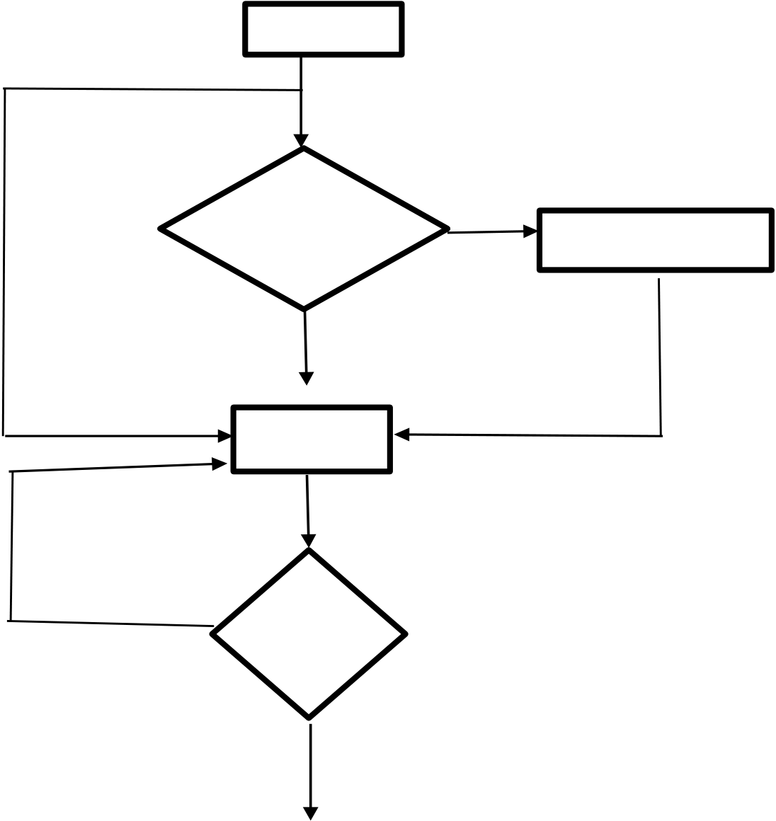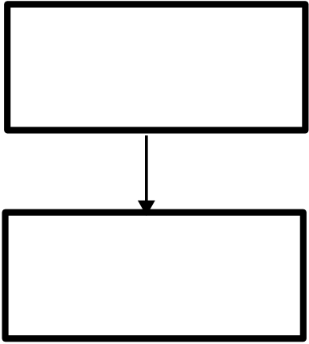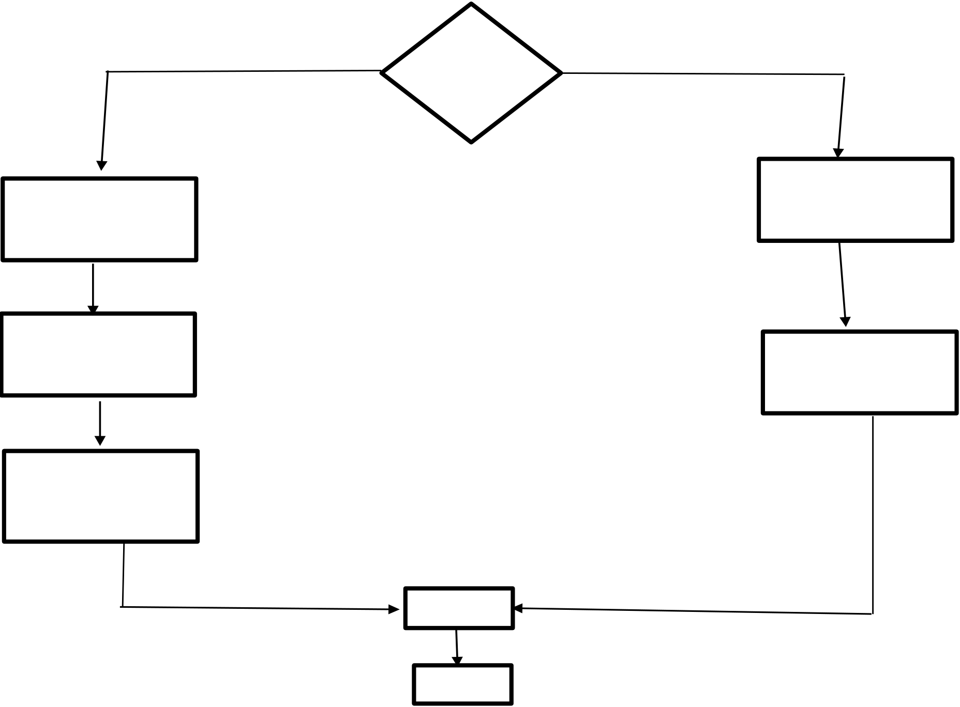

|  |  |  |  |  |  |  |  |  |  |  |  |  |  |
| --- | --- | --- | --- | --- | --- | --- | --- | --- | --- | --- | --- | --- | --- |
| **SYSTEM DESIGN**  **Flow Chart:**  Start  User   |  |  |  |  | | --- | --- | --- | --- | |  | If  Registere | no | Registra4on |     yes  login       |  |  |  | | --- | --- | --- | |  | No | Is | | valid |     Yes    Yes No Is   Admin   |  |  | | --- | --- | | Admin  Add Car Details | Use  Car Search |   Add   |  |  | | --- | --- | | Update Car Details | Car Reserved |   Travelling  Informa4on   Update  logout  stop  **26** | |
|

|  |  |
| --- | --- |
| **DATA FLOW DIAGRAM**  **DFD** is the abbreviation for **Data Flow Diagram**. The flow of data of a system or a process is represented by DFD. It also gives insight into the inputs and outputs of each entity and the process itself. DFD does not have control flow and no loops or decision rules are present. Specific operations depending on the type of data can be explained by a flowchart. Data Flow Diagram can be represented in several ways. The DFD belongs to structured-analysis modelling tools. Data Flow diagrams are very popular because they help us to visualize the major steps and data involved in software-system processes.  **Levels of DFD**  DFD uses hierarchy to maintain transparency thus multilevel DFD’s can be created. Levels of DFD are as follows:  Ø0-level DFD  Ø1-level DFD  Ø2-level DFD  **Advantages of DFD**   ØIt helps us to understand the functioning and the limits of a system. ØIt is a graphical representation which is very easy to understand as it helps visualize contents.  ØData Flow Diagram represent detailed and well explained diagram of system components.  ØIt is used as the part of system documentation file.  ØData Flow Diagrams can be understood by both technical or nontechnical person because they are very easy to understand.  **27** | |
|

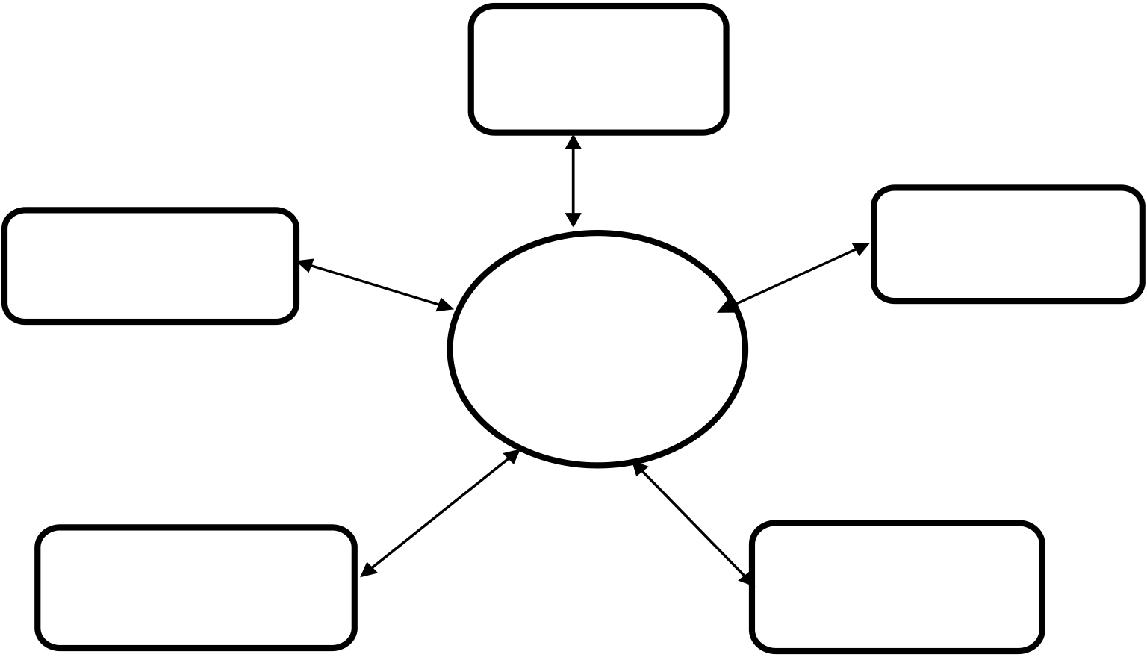

|  |  |  |  |  |  |  |  |  |  |  |  |  |  |  |
| --- | --- | --- | --- | --- | --- | --- | --- | --- | --- | --- | --- | --- | --- | --- |
| **Disadvantages of DFD**   ØAt times DFD can confuse the programmers regarding the system. ØData Flow Diagram takes long time to be generated, and many times due to this reasons analysts are denied permission to work on it.  **Zero Level DFD:**  It is also known as a context diagram. It’s designed to be an abstraction view, showing the system as a single process with its relationship to external entities.  It represents the entire system as a single bubble with input and output data indicated by incoming/outgoing arrows. It should be easily understood by a wide audience, including stakeholders, business analysts, data analysts and developers.  management Booking   |  |  |  |  | | --- | --- | --- | --- | |  | Car | Car Rental | Customer | |  | | management | | management | |  | | System |      |  |  |  | | --- | --- | --- | |  | Login management | System User | | management |   Zero Level DFD –Car Rental System  **28** | |
|

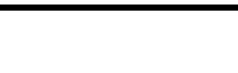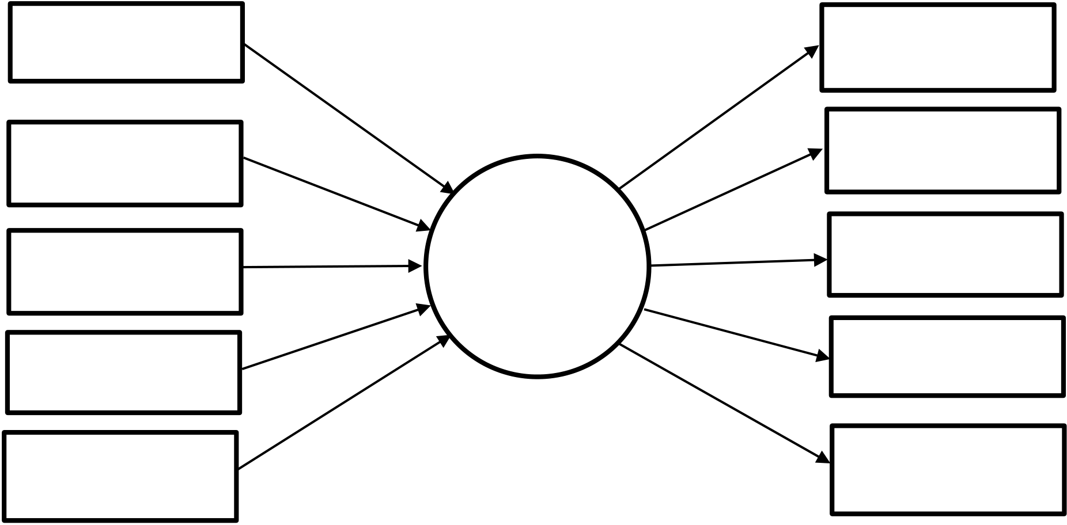

|  |  |  |  |  |  |  |  |  |  |  |  |  |  |  |  |  |  |  |  |
| --- | --- | --- | --- | --- | --- | --- | --- | --- | --- | --- | --- | --- | --- | --- | --- | --- | --- | --- | --- |
| **irst Level DFD:**  In 1-level DFD, the context diagram is decomposed into multiple  bubbles/processes. In this level, we highlight the main functions of the system and breakdown the high-level process of 0-level DFD into sub processes. Level 1 DFD also mentions basic processes and sources of information.  ØIt provides a more detailed view of the Context Level Diagram.  ØHere, the main functions carried out by the system are highlighted as we break into its sub-processes.  Car management Generate car report   |  |  |  | | --- | --- | --- | | Booking | Car rental | Generate booking | | report | | management | | Customer | Generate | | system | | customer report | | management | | Login | Check user login | | details | | management | | System user | Generate system | | management | user report |   First level DFD – car rental system  **29** | |
|

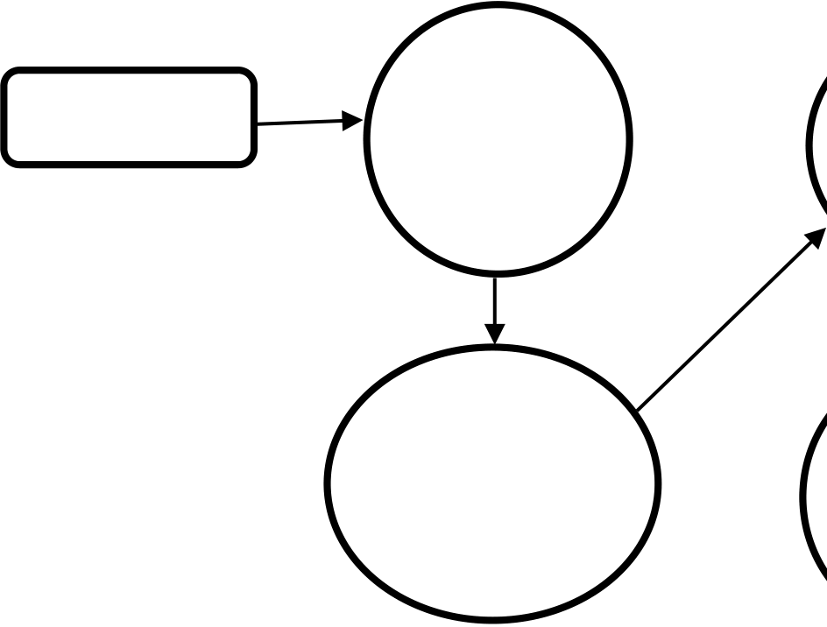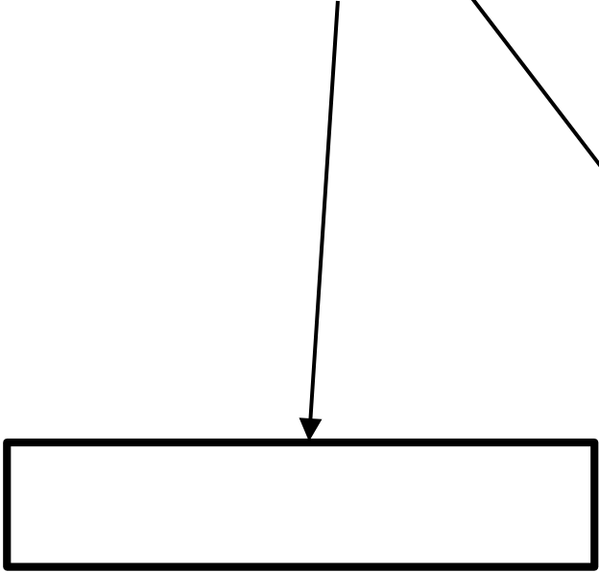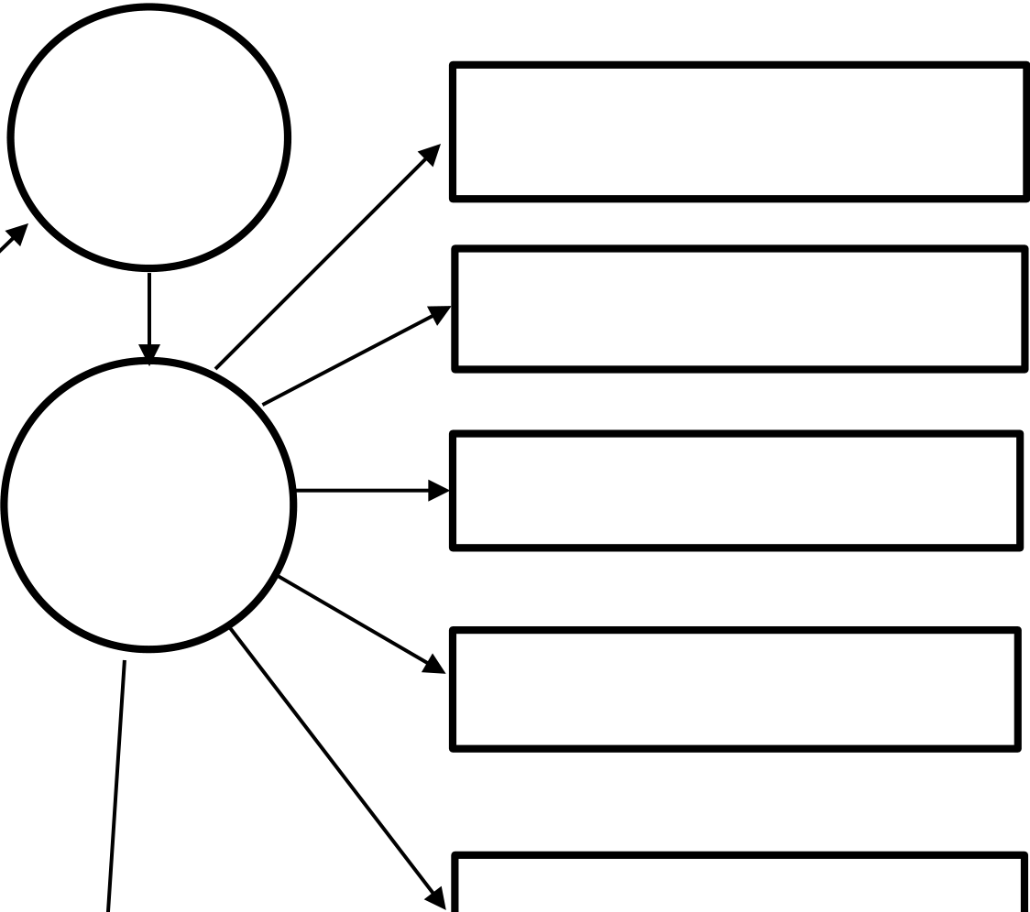

|  |  |  |  |  |  |  |  |  |  |  |  |  |  |  |  |  |
| --- | --- | --- | --- | --- | --- | --- | --- | --- | --- | --- | --- | --- | --- | --- | --- | --- |
| **Second Level DFD:**  2-level DFD goes one step deeper into parts of 1-level DFD. It can be used to  plan or record the specific/necessary detail about the system’s functioning.   |  |  |  |  | | --- | --- | --- | --- | | Admin | Login to | Check | Manage Car Details | | system | | roles of |   access  Manage Customer Details   |  |  |  |  | | --- | --- | --- | --- | |  | Check | Manage | Manage Booking Details | | creden4als | | modules | | Manage Rent Details |     Manage Reports      Manage User permission     |  |  | | --- | --- | |  | Second level DFD –Car Rental System |   **30** | |
|

|  |  |  |  |  |  |  |  |  |  |  |  |  |  |  |  |  |  |  |  |  |  |  |  |  |  |  |  |  |  |  |  |  |  |  |  |  |  |  |  |  |  |  |  |  |  |  |  |  |  |  |  |  |  |
| --- | --- | --- | --- | --- | --- | --- | --- | --- | --- | --- | --- | --- | --- | --- | --- | --- | --- | --- | --- | --- | --- | --- | --- | --- | --- | --- | --- | --- | --- | --- | --- | --- | --- | --- | --- | --- | --- | --- | --- | --- | --- | --- | --- | --- | --- | --- | --- | --- | --- | --- | --- | --- | --- |
| **DATABASE DIAGRAM**  **Admin:**   |  |  |  |  | | --- | --- | --- | --- | | **Sno** | **Column name** | **Datatype** | **Constraint** | | **1** | **ID** | **int(10)** | **Primary key** | | **2** | **Username** | **varchar(50)** | **Not null** | | **3** | **Password** | **varchar(50)** | **Not null** |   **Tblusers:**   |  |  |  |  | | --- | --- | --- | --- | | **Sno** | **Column name** | **Datatype** | **Constraint** | | **1** | **ID** | **int(10)** | **Primary key** | | **2** | **Full Name** | **varchar(50)** | **Not null** | | **3** | **Password** | **varchar(50)** | **Not null** | | **4** | **Email ID** | **varchar(50)** | **Not null** | | **5** | **Contact Number** | **number(10)** | **Not null** | | **6** | **Address** | **varchar(50)** | **Not null** | | **7** | **City** | **varchar(50)** | **Allow null** | | **8** | **Country** | **varchar(50)** | **Allow null** |   **31** | |
|

|  |  |  |  |  |  |  |  |  |  |  |  |  |  |  |  |  |  |  |  |  |  |  |  |  |  |  |  |  |  |  |  |  |  |  |  |  |  |  |  |  |  |  |  |  |  |  |  |  |  |  |  |  |  |  |  |  |  |
| --- | --- | --- | --- | --- | --- | --- | --- | --- | --- | --- | --- | --- | --- | --- | --- | --- | --- | --- | --- | --- | --- | --- | --- | --- | --- | --- | --- | --- | --- | --- | --- | --- | --- | --- | --- | --- | --- | --- | --- | --- | --- | --- | --- | --- | --- | --- | --- | --- | --- | --- | --- | --- | --- | --- | --- | --- | --- |
| **Tblbrands:**   |  |  |  |  | | --- | --- | --- | --- | | **Sno** | **Column name** | **Datatype** | **Constraint** | | **1** | **ID** | **int(10)** | **Primary key** | | **2** | **Brand Name** | **varchar(50)** | **Not null** | | **3** | **Creation date** | **Timestamp** | **Not null** | | **4** | **Updating date** | **Timestamp** | **Not null** |   **Tblbookings:**   |  |  |  |  | | --- | --- | --- | --- | | **Sno** | **Column name** | **Datatype** | **Constraint** | | **1** | **ID** | **int(10)** | **Primary key** | | **2** | **Booking Number** | **bigint(12)** | **Not null** | | **3** | **User email** | **varchar(50)** | **Not null** | | **4** | **Vehicles id** | **int(11)** | **Not null** | | **5** | **From date** | **varchar(50)** | **Not null** | | **6** | **To date** | **varchar(50)** | **Not null** | | **7** | **Message** | **varchar(50)** | **Not null** | | **8** | **Status** | **int(10)** | **Not null** |   **32** | |
|

|  |  |  |  |  |  |  |  |  |  |  |  |  |  |  |  |  |  |  |  |  |  |  |  |  |  |  |  |  |  |  |  |  |  |  |  |  |  |  |  |  |  |  |  |  |  |  |  |  |  |  |  |  |  |  |  |  |  |  |  |  |  |
| --- | --- | --- | --- | --- | --- | --- | --- | --- | --- | --- | --- | --- | --- | --- | --- | --- | --- | --- | --- | --- | --- | --- | --- | --- | --- | --- | --- | --- | --- | --- | --- | --- | --- | --- | --- | --- | --- | --- | --- | --- | --- | --- | --- | --- | --- | --- | --- | --- | --- | --- | --- | --- | --- | --- | --- | --- | --- | --- | --- | --- | --- |
| **Tblvehicles:**   |  |  |  |  | | --- | --- | --- | --- | | **Sno** | **Column name** | **Datatype** | **Constraint** | | **1** | **ID** | **int(10)** | **Primary key** | | **2** | **Vehicles title** | **varchar(50)** | **Not null** | | **3** | **Vehicles brand** | **int(11)** | **Not null** | | **4** | **Vehicles overview** | **longtext** | **Not null** | | **5** | **Price per day** | **int(11)** | **Not null** | | **6** | **Fuel type** | **varchar(50)** | **Not null** | | **7** | **Model year** |  | **Not null** | | **8** | **Seating capacity** | **int(10)** | **Not null** | | **9** | **Vimage1** | **varchar(120)** | **Not null** | | **10** | **Vimage2** | **varchar(120)** | **Not null** | | **11** | **Vimage3** | **varchar(120)** | **Not null** | | **12** | **Vimage4** | **varchar(120)** | **Not null** | | **13** | **Vimage5** | **varchar(120)** | **Not null** | | **14** | **Regdate** | **Timestamp** | **Not null** |   **SYSTEM IMPLEMENTATION-MODULE DESCRIPTION**  This project has the following main modules:   • Administrator Module   • User Module  **1.Administrator Module:**  **33** | |
|

|  |  |
| --- | --- |
| The administrator is the owner of this Ecommerce website. he is responsible for the creation and maintenance of the accounts to the system .Admin is responsible for the creation of different kind of managers .Admin looks after the maintenance of these accounts. He has a feature of getting the password of a username  The administrator can perform the following functions:   I) Login Control Panel   II) Summary Page   III)Add/Edit Cars Details, Image &Price   IV)Home Page Cars Display  **2. Users Module:**  The users of this online car rental application are all customers who would rent to test the application. These users are anyone with renting experience and the knowhow to browse through a car rental application. They must have basic understandings about computers and the internet.  The users should be able to perform the following functions using this system: I)View, browse, and select a category on the home page.  II)View, add, and update items in the cart.  III)Delete items from the cart.  IV)Check out the items from the application or continue shopping. V)Sign-up/login using a username and password. VI)Place the order by completing the order form.  **34** | |
|

|  |  |
| --- | --- |
| **INPUT / OUTPUT**   **User module**  **Home page:**    **User Registration Form:**    **35** | |
|

|  |  |
| --- | --- |
| **User Login Form:**    **Vehicles Page:**    **36** | |
|

|  |  |
| --- | --- |
| **Car Booking Page:**    **About Us Page:**    **37** | |
|

|  |  |
| --- | --- |
| **Admin module:**  **Admin Login Page:**    **Dashboard:**    **38** | |
|

|  |  |
| --- | --- |
| **Create Brand Page:**    **Manage Brands Page:**    **39** | |
|

|  |  |
| --- | --- |
| **Post Vehicles Page:**    **Manage Vehicles Page:**    **40** | |
|

|  |  |
| --- | --- |
| **New Booking Page:**    **41** | |
|

|  |  |  |  |  |
| --- | --- | --- | --- | --- |
| SAMPLE CODE  **User Module:**  **Index.php** <?php  session_start();  include('includes/config.ph  p'); error_reporting(0);  ?>  <!DOCTYPE HTML>  <html lang="en">  <head>  <title>Car Rental</title>  <!--Bootstrap -->  <link rel="stylesheet" href="assets/css/bootstrap.min.css" type="text/css"> <link rel="stylesheet" href="assets/css/style.css" type="text/css">  <link rel="stylesheet" href="assets/css/owl.carousel.css" type="text/css"> <link rel="stylesheet" href="assets/css/owl.transitions.css" type="text/css"> <link href="assets/css/slick.css" rel="stylesheet">  <link href="assets/css/bootstrap-slider.min.css" rel="stylesheet">  <link href="assets/css/font-awesome.min.css" rel="stylesheet"> <link rel="apple-touch-icon-precomposed" sizes="144x144"  href="assets/images/favicon-icon/apple-touch-icon-144- precomposed.png">   |  |  |  | | --- | --- | --- | | <link | rel="apple-touch-icon-precomposed" | sizes="114x114" |   href="assets/images/favicon-icon/apple-touch-icon-114-precomposed.html"> <link rel="apple-touch-icon-precomposed" sizes="72x72"  href="assets/images/favicon-icon/apple-touch-icon-72-precomposed.png"> <link rel="apple-touch-icon-precomposed"  href="assets/images/faviconicon/apple-touch-icon-57-precomposed.png">  **42** | |
|

|  |  |
| --- | --- |
| <link rel="shortcut icon" href="assets/images/favicon-icon/favicon.png"> <link href="https://fonts.googleapis.com/css?family=Lato:300,400,700,900" rel="stylesheet">  <style>  .container{  position:  relative;   }   .container .card{  position: relative;  width: 320px;  height: 450px;  background:  #232323; border- radius: 20px;  overflow: hidden;   }   .container  .card:before{  content: '';  position: absolute;  top: 0; left: 0;   width: 100%; height: 100%;  background: #9bdc28; clip-path:  circle(150px at 80% 20%);  transition: 0.5s ease-in-out;   }   .container .card:hover:before{ clip- path: circle(300px at 80% -20%);  **43** | |
|

|  |  |
| --- | --- |
| }   .container .card:after{  content: 'Rent'; position:  absolute; top: 30%;  left: -20%; font-size:  12em; font-weight: 800;  font-style: italic; color:  rgba(255,255,25,0.05)   }   .container .card .imgBx{  position: absolute; top:  50%; transform:  translateY(-50%); z- index: 10000; width:  100%; height: 220px;  transition: 0.5s;   }   .container .card:hover  .imgBx{ top: 0%;  transform: translateY(0%);   }   .container .card .imgBx img{  position: absolute; top: 50%;  left: 50%; transform:  translate(-50%, -50%) ;  width: 270px;   }   .container .card  .contentBx{ position:  **44** | |
|

|  |  |  |  |  |
| --- | --- | --- | --- | --- |
| absolute; bottom: 0;  width: 100%; height:  100px; text-align:  center; transition: 1s;  z-index: 10;   }   |  |  |  | | --- | --- | --- | | .container | .card:hover | .contentBx{ |   height: 200px;   }   .container .card .contentBx  h2{ position: relative;  font-weight: 600; letter- spacing: 1px; color: #fff;  margin: 0;   }   .container .card .contentBx .size, .container .card .contentBx .color { display: flex; justify-content: center; align-items: center; padding: 8px 20px;   transition: 0.5s;opacity: 0;  visibility: hidden; padding- top: 0; padding-bottom: 0;   }   .container .card:hover .contentBx  .size{ opacity: 1; visibility:  visible; transition-delay: 0.5s;   }   .container .card:hover .contentBx  .color{ opacity: 1; visibility:  visible; transition-delay: 0.6s;   }  **45** | |
|

|  |  |  |  |  |  |  |  |  |  |  |  |
| --- | --- | --- | --- | --- | --- | --- | --- | --- | --- | --- | --- |
| .container .card .contentBx .size h3, .container .card .contentBx .color h3{ color: #fff; font-weight: 400; font-size: 18px; text-transform: uppercase; letter-spacing: 2px; margin-right: 10px; }   .container .card .contentBx .size  span{ width: 100px; height:  26px; text-align: center; line- height: 26px; font-weight: 800;  font-size: 14px; display: inline- block; color: #111;   background: #fff;   margin: 0 5px;   transition: 0.5s;   color: #111;   border-radius: 4px;  cursor: pointer;   }   |  |  |  |  |  | | --- | --- | --- | --- | --- | | .container | .card | .contentBx | .size | span:hover{ |   background: #9bdc28;   }   .container .card .contentBx .color  span{ width: 20px; height:  20px; background: #ff0; border- radius: 50%; margin: 0 5px;  cursor: pointer;   }   |  |  |  |  |  | | --- | --- | --- | --- | --- | | .container | .card | .contentBx | .color | span:nth-child(2){ |   background: #9bdc28;   }  **46** | |
|

|  |  |  |  |  |  |  |  |  |  |  |  |
| --- | --- | --- | --- | --- | --- | --- | --- | --- | --- | --- | --- |
| |  |  |  |  |  | | --- | --- | --- | --- | --- | | .container | .card | .contentBx | .color | span:nth-child(3){ |   background: #03a9f4;   }   |  |  |  |  |  | | --- | --- | --- | --- | --- | | .container | .card | .contentBx | .color | span:nth-child(4){ |   background: #e91e63;   }   .container .card .contentBx  a{ display: inline-block;  padding: 10px 20px;  background: #fff;  border-radius: 4px;  margin-top: 10px; text- decoration: none; font- weight: 600; color:  #111;   opacity: 0; transform:   translateY(50px);   transition: 0.5s; margin-  top: 0;   }   .container .card:hover .contentBx  a{ opacity: 1; transform:  translateY(0px); transition- delay: 0.75s;   }   </style>  </head>  <body>  <!--Header-->  **47** | |
|

|  |  |
| --- | --- |
| <?php include('includes/header.php');?>  <!-- /Header -->  <!-- Banners -->  <section id="banner" class="banner-section">   <div class="container">   <div class="div_zindex">   <div class="row">   <div class="col-md-5 col-md-push-7">   <div class="banner_content">   <h1>&nbsp;</h1>   <p>&nbsp; </p>   </div>   </div>   </div>   </div>   </div>  </section>  <!-- /Banners -->  <!-- Resent Cat-->  <section class="section-padding gray-bg">   <div class="container">   <div class="section-header text-center">   <h2>Find the Best <span>CarForYou</span></h2>   <p>There are many variations of passages of Lorem Ipsum available, but the majority have suffered alteration in some form, by injected humour, or  randomised words which don't look even slightly believable. If you are going to  **48** | |
|

|  |  |  |  |  |  |
| --- | --- | --- | --- | --- | --- |
| use a passage of Lorem Ipsum, you need to be sure there isn't anything embarrassing hidden in the middle of text.</p>   </div>   <div class="row">  <!-- Nav tabs -->   <div class="recent-tab">   <ul class="nav nav-tabs" role="tablist">   |  |  |  |  | | --- | --- | --- | --- | | <li | role="presentation" | class="active"><a | href="#resentnewcar" |   role="tab" data-toggle="tab">New Car</a></li>   </ul>   </div>   <!-- Recently Listed New Cars -->   <div class="tab-content">   <div role="tabpanel" class="tab-pane active" id="resentnewcar">  <?php $sql = "SELECT  tblvehicles.VehiclesTitle,tblbrands.BrandName,tblvehicles.PricePerDay,tblvehicl e  s.FuelType,tblvehicles.ModelYear,tblvehicles.id,tblvehicles.SeatingCapacity,tblv e hicles.VehiclesOverview,tblvehicles.Vimage1 from tblvehicles join tblbrands on tblbrands.id=tblvehicles.VehiclesBrand limit 9";  $query = $dbh -> prepare($sql);  $query->execute();  $results=$query->fetchAll(PDO::FETCH_OBJ);  $cnt=1; if($query- >rowCount() > 0)  { foreach($results as  $result)  **49** | |
|

|  |  |  |  |  |  |  |  |  |  |  |  |  |  |  |  |
| --- | --- | --- | --- | --- | --- | --- | --- | --- | --- | --- | --- | --- | --- | --- | --- |
| {  ?>  <div class="col-list-3">  <div class="recent-car-list">  <div class="car-info-box"> <a href="vehical-details.php?vhid=<?php echo htmlentities($result->id);?>"><img src="admin/img/vehicleimages/<?php echo htmlentities($result->Vimage1);?>" class="img-responsive" alt="image"></a> <ul>  <li><i class="fa fa-car" aria-hidden="true"></i><?php echo htmlentities($result- >FuelType);?></li>   |  |  |  |  |  | | --- | --- | --- | --- | --- | | <li><i | class="fa | fa-calendar" | aria-hidden="true"></i><?php | echo |   htmlentities($result->ModelYear);?> Model</li>   |  |  |  |  |  | | --- | --- | --- | --- | --- | | <li><i | class="fa | fa-user" | aria-hidden="true"></i><?php | echo |   htmlentities($result-  >SeatingCapacity);?> seats</li>  </ul>  </div>  <div class="car-title-m">   |  |  |  |  | | --- | --- | --- | --- | | <h6><a | href="vehical-details.php?vhid=<?php | echo | htmlentities($result- |   >id);?>">  <?php echo htmlentities($result->VehiclesTitle);?></a></h6>  <span class="price">Rs<?php echo htmlentities($result->PricePerDay);?> /Day</span>  </div>  <div class="inventory_info_m">  <p><?php echo substr($result->VehiclesOverview,0,70);?></p>  </div>  </div>  </div>  **50** | |
|

|  |  |
| --- | --- |
| <?php }}?>  </div>   </div>   </div>  </section>  <!-- /Resent Cat -->  <!--Footer -->  <?php include('includes/footer.php');?>  <!-- /Footer-->  <!--Back to top-->  <div id="back-top" class="back-top"> <a href="#top"><i class="fa fa-angle-up" aria-hidden="true"></i> </a> </div>  <!--/Back to top-->  <!--Login-Form -->  <?php include('includes/login.php');?>  <!--/Login-Form -->  <!--Register-Form -->  <?php include('includes/registration.php');?> <!--/Register-Form -->  <!-- Scripts -->  <script src="assets/js/jquery.min.js"></script> <script src="assets/js/bootstrap.min.js"></script> <script src="assets/js/interface.js"></script>  <!--Switcher-->  **51** | |
|

|  |  |
| --- | --- |
| <script src="assets/switcher/js/switcher.js"></script> <!--bootstrap-slider-JS-->  <script src="assets/js/bootstrap-slider.min.js"></script> <!--Slider-JS-->  <script src="assets/js/slick.min.js"></script>  <script src="assets/js/owl.carousel.min.js"></script> </body>  </html>  **Login.php**  <?php  if(isset($_POST['login']  )) {  $email=$_POST['email'];  $password=md5($_POST['password']);  $sql ="SELECT EmailId,Password,FullName FROM tblusers WHERE EmailId=:email and Password=:password";  $query= $dbh -> prepare($sql);  $query-> bindParam(':email', $email, PDO::PARAM_STR);  $query-> bindParam(':password', $password, PDO::PARAM_STR);  $query-> execute();  $results=$query->fetchAll(PDO::FETCH_OBJ); if($query- >rowCount() > 0)  {  $_SESSION['login']=$_POST['email'];  $_SESSION['fname']=$results->FullName;  **52** | |
|

|  |  |  |  |  |  |  |  |  |
| --- | --- | --- | --- | --- | --- | --- | --- | --- |
| $currentpage=$_SERVER['REQUEST_URI'];  echo "<script type='text/javascript'> document.location = '$currentpage'; </script>"; } else{  echo "<script>alert('Invalid Details');</script>";  }  }  ?>  <div class="modal fade" id="loginform">   <div class="modal-dialog" role="document">   <div class="modal-content">   <div class="modal-header">   |  |  |  |  | | --- | --- | --- | --- | | <button | type="button" | class="close" | data-dismiss="modal" |   arialabel="Close"><span aria-hidden="true">&times;</span></button> <h3 class="modal-title">Login</h3>   </div>   <div class="modal-body">   <div class="row">   <div class="login_wrap">   <div class="col-md-12 col-sm-6">   <form method="post">   <div class="form-group">   |  |  |  | | --- | --- | --- | | <input type="email" | class="form-control" | name="email" |   placeholder="Email address*">   </div>  **53** | |
|

|  |  |
| --- | --- |
| <div class="form-group">   <input type="password" class="form-control"   name="password" placeholder="Password*">   </div>   <div class="form-group checkbox">   <input type="checkbox" id="remember">   </div>   <div class="form-group">   <input type="submit" name="login" value="Login" class="btn btnblock">   </div>   </form>   </div>   </div>   </div>   </div>   <div class="modal-footer text-center">   <p>Don't have an account? <a href="#signupform" data-toggle="modal" datadismiss="modal">Signup Here</a></p>   </div>   </div>   </div>  </div>  **54** | |
|

|  |  |
| --- | --- |
| **FUTURE ENHANCEMENT**  Every Edition of a book comes with new topics and modifications if any errors are present. In the similar way, in near future, our application will overcome the flaws if occurred, and attains new features offered to the Flexible and easy Transportation. Following are the Enhancements to the application.  ØProviding Good User Interface.  ØTry to Implement the GPS system in the Cabs.  **55** | |
|

|  |  |
| --- | --- |
| **CONCLUSION**  Car Rental System is a Web application and it is restricted to only Registered type of users. In this application Admin have been given access rights and they are restricted up to their functionalities, so that the data is maintained securely and redundant data is prevented. As the Data is stored electronically, it is necessary to have a Computer and Network connection to access the Application.  **56** | |
|

|  |  |
| --- | --- |
| **BIBLIOGRAPHY**  During the development of project, we have used the following books.  **BOOKS:**  PHP6 and MYSQL   (By: Steve Ushering Tim Converse Joyce Park)  P**HP Cookbook**   (By: David Skylar Adam Trachtenberg)  **57** | |
|